Grille de satisfaction

  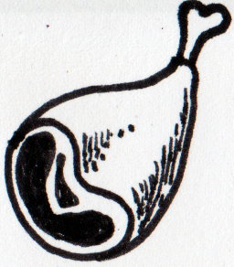  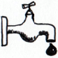  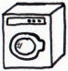    Critères | Tour 1 |  | Tour 2 |  | Tour 3 |  | Tour 4 |  | Tour 5 |  | Tour 6 |  | Tour 7 |  | Tour 8
Espéré / Satisfait | E | S | E | S | E | S | E | S | E | S | E | S | E | S | E | S
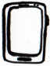

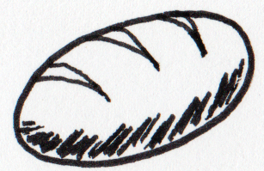
= +
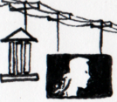
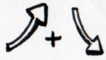
Satisfaction

Population
Production

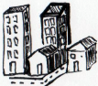
Coûts
Besoins  :  x =  Services  = +  X = + | Limites |  |  |  |  |  | par | total
 | 1 3
= +
 | 3,5 4,5
 | 0,5 3
soit | /
 | 0,5 3
 | /
 | /
 | 1/15 1/3

Agriculture et assimilés
Zone de captage

Surface totale :
dont construite :
Soit surface de captage :

x =
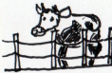  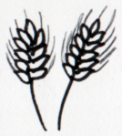 | Nombre | Coût |  |  |  |  |  | Production
 | Nombre |  | total |  | total |  | total | ou
Champs |  |  |  |  |  |  |  | x7
Élevage |  |  |  |  |  |  |  | x3
Total

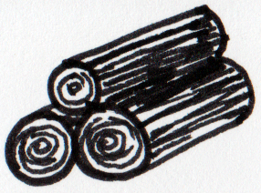
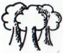
Coûts
Forêt

En construction : =
(délai : 1 tour)

Coupée : =

Production
Extraction

Mines et carrières
Éoliennes

x =

Usure 1
2
3
4
5
6
7

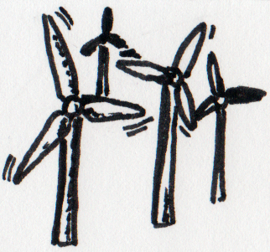
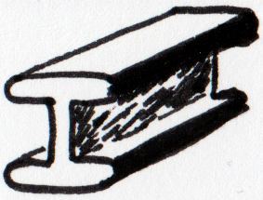  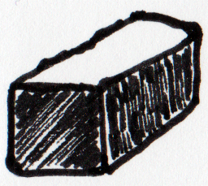  Nom  Coûts  Production | Age |  |  |  |  |  | coût |  |  | Production
Met 1
Met 2
Met 3
Met 4
Car 1
Met 5
Met 6
Met 7
Total
Production
Coûts
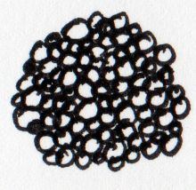  Nom  Production | Age |  |  |  |  | Coût |  |  |  | Prod. |  | Nom | Age |  |  |  |  | Coût |  |  |  | Prod.
EM 1 |  |  |  |  |  |  |  |  |  |  |  | HiFi 1
EM 2 |  |  |  |  |  |  |  |  |  |  |  | HiFi 2
EM 3 |  |  |  |  |  |  |  |  |  |  |  | HiFi 3
EM 4 |  |  |  |  |  |  |  |  |  |  |  | HiFi 4
EM 5 |  |  |  |  |  |  |  |  |  |  |  | HiFi 5
EM 6 |  |  |  |  |  |  |  |  |  |  |  | HiFi 6
EM 7 |  |  |  |  |  |  |  |  |  |  |  | HiFi 7
EM 8 |  |  |  |  |  |  |  |  |  |  |  | HiFi 8
 |  |  |  |  |  |  |  |  |  |  |  | HiFi 9
Total |  |  |  |  |  |  |  |  |  |  |  | Total
Énergie
Coûts

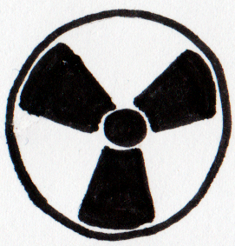  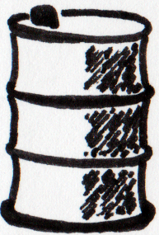  Nom  Production | Age |  |  |  |  | Coût |  | Prod. |  | Nom | Age |  |  |  |  | Coût |  |  |  | Prod.
Nuc 1 |  |  |  |  |  |  |  |  |  | Raf 1
Nuc 2 |  |  |  |  |  |  |  |  |  | Raf 2
Nuc 3 |  |  |  |  |  |  |  |  |  | Raf 3
Nuc 4 |  |  |  |  |  |  |  |  |  | Raf 4
Nuc 5 |  |  |  |  |  |  |  |  |  | Raf 5
Nuc 6 |  |  |  |  |  |  |  |  |  | Raf 6
Nuc 7 |  |  |  |  |  |  |  |  |  | Raf 7
Nuc 8 |  |  |  |  |  |  |  |  |  | Raf 8
Nuc 9 |  |  |  |  |  |  |  |  |  | Raf 9
Nuc 10
Nuc 11
Nuc 12
Nuc 13
Nuc 14
Total |  |  |  |  |  |  |  |  |  | Total
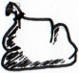
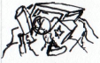
Déchets
x =
Coûts
A enfouirEnfouis Restant
restant + nouveaux
x : + + + = + +
x : + =
+ + + = + +
valorisation énergétique
nouveaux = total – (valorisation énergétique + recyclage)
recyclage
Production
enfouissage
+ =
/ :
=

Import
Ressource | Tour 1 |  | Tour 2 |  | Tour 3 |  | Tour 4 |  | Tour 5 |  | Tour 6 |  | Tour 7 |  | Tour 8
Ressource | Payé | Arrive | Payé | Arrive | Payé | Arrive | Payé | Arrive | Payé | Arrive | Payé | Arrive | Payé | Arrive | Payé | Arrive
Coût
Ressource | Tour 1 |  |  | Tour 2 |  |  | Tour 3 |  |  | Tour 4 |  |  | Tour 5 |  |  | Tour 6 |  |  | Tour 7 |  |  | Tour 8
Nécessaire / Capacité / Produit | N | C | P | N | C | P | N | C | P | N | C | P | N | C | P | N | C | P | N | C | P | N | C | P
= +

Améliorations & bâtiments supplémentaires

 | Nombre | Coût |  |  |  |  |  |  |  | Production
 | Nombre | Ress. | total | Ress. | total | Ress. | total | Ress. | total | Ress. | total | Ress. | total | Ress. | total
Coûts
Production

